CCGC5003

Python Project Phase 2

Suraj Mandal

Venkata Narasimha Vedavyas Muppavarapu

03/27/2023

CHAT APPLICATION

# Web page design

## Login Page:

This is the landing page of our chat application. Once the user has created an account, they can log in to the application directly. The login functionality, logs in the user to chat app, the information stored in the firebase database to verify their identity via google authentication.

**Landing page:**

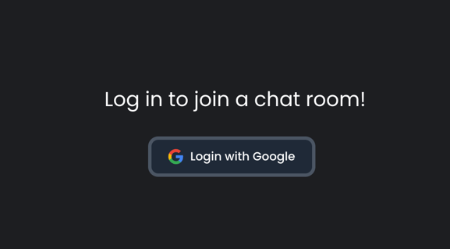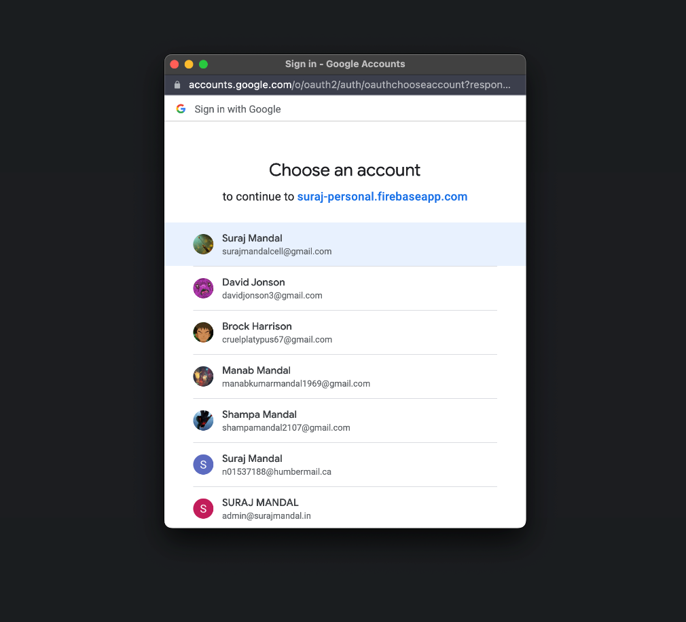

**Valid username and password (Login success)**

If the user's login credentials are valid, the application would create a session for the user and redirect them to chatroom page.

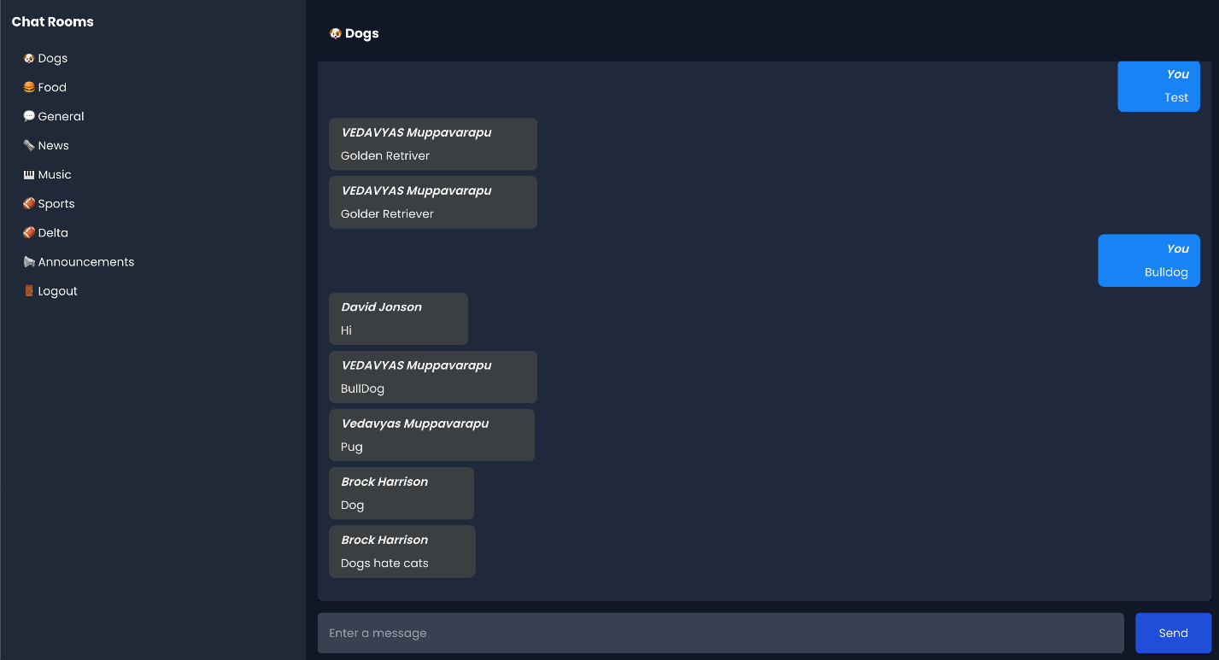

Chat rooms:

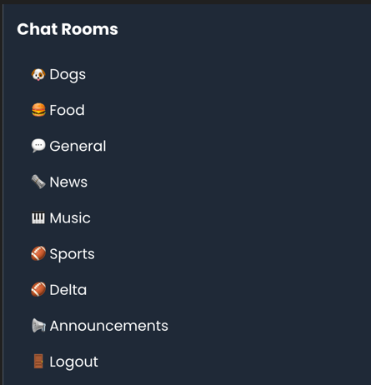

This will display chat rooms available with announcements that user will collaborate.

## Announcements:

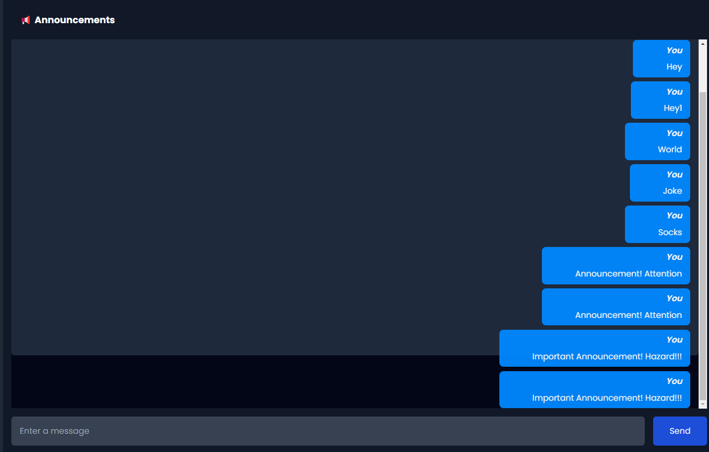

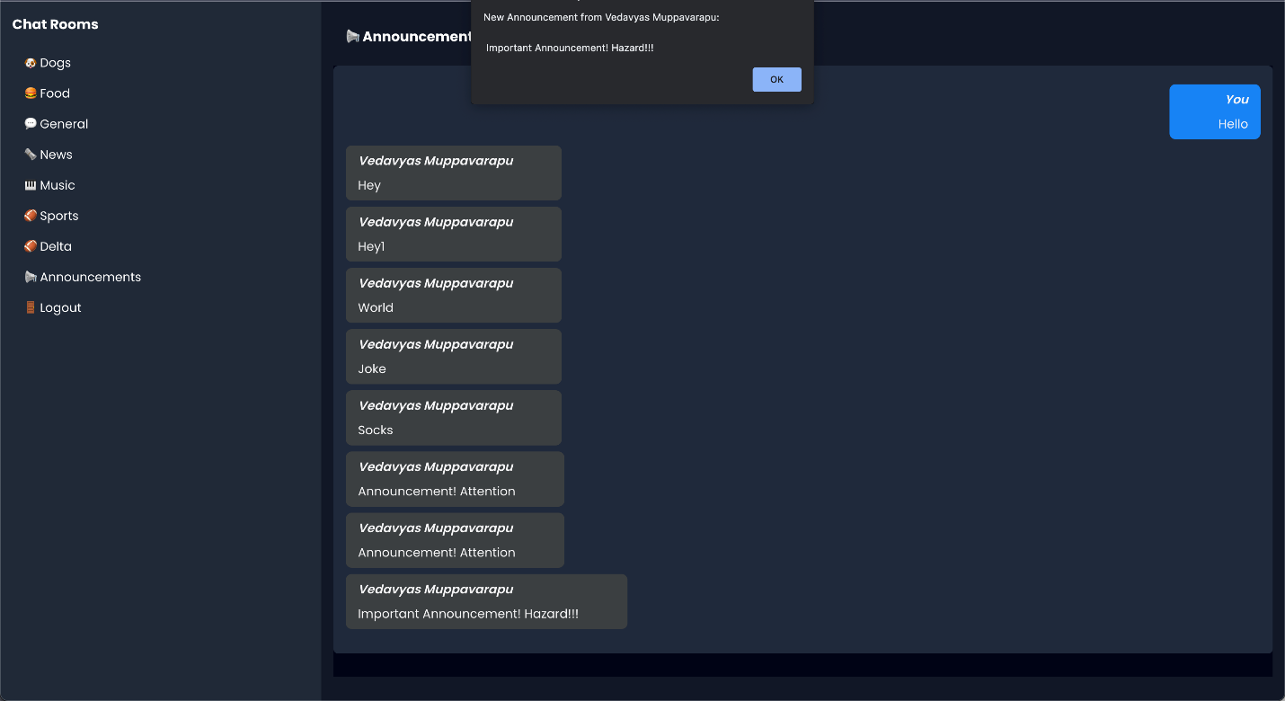

## Changes made in Phase -3:

We have added firebase auth which handles google authentication and authorization. Changed UI design in frontend to look more materialistic. Added logout functionality.

## Team member contribution

**Venkata Narasimha Vedavyas Muppavarapu**

Worked on creating Login UI pages, chat room UI. Will be working with integrating firebase with react app

**Suraj Mandal**

Worked on creating chat rooms, firebase authentication, message queuing. Will be working the flask to host react app